HOW TO CHECK YOU TAXA WITH WORMS

***EKlein. March 2019***

This is a review of the procedure you must follow to obtain the **accepted scientific name** and its **corresponding ID (LSID)** of your taxa from WoRMS.

This is the same for the Rocky Shore and Sandy Beach with the difference where the names of the collected/observed organisms are in the standard tables.

1. In all the cases we have the taxon name in columns, starting at cell W1 in the sandy beach table and in H16 for the Abundance sheet and J16 for the Cover.

2. In the COVER sheet, the cell H16 and I16 contain the names "Bare Rock" and "Withouth sustrate". Do not change that cells even if the last one has a bad orthography. The code take care of that

3. Please be sure that there is no scientific name associated to any organisms. For example you will never find a match for something called "Gusano Peludo Verde" ("Green Hairy Worm"). Identify it to the lowest taxonomic rank possible, like *Polychaeta*. If you don't know the exact scientific name, leave it at the lowest taxonomic rank possible. Names like *Ulva* sp. or *Ulva* spp. are allowed as WoRMS will find a match at the genus level

4. DO NOT include the authority name in the taxon name. This will difficult in most of the cases the match. If there is an ambiguity in the author you will have the opportunity to correct it later.

5. ACTION: Starting with the Abundance sheet, select ALL the taxonomic names from from table and copy then to the clipboard (CTRL-C)

6. ACTION: open a new empty excel sheet. Paste the taxonomic names in a transposed format, i.e. one name PER ROW. To do that do PASTE SPECIAL and select TRANSPOSE in the options. That could vary according to you excel version

7. ACTION: save the new table with the taxonomic names in row as a **CSV** file. This is done using the save as.. command. Please name the file **taxonameAbund.csv**. This will produce a flat text file with the taxon names. If you're tempted to open the file with the infamous Notepad, please DO NOT save it again, just close it without saving. Although you can use Notepad to view the content of the file, just be careful to not save it again, Notepad will introduce some alien codes in the file.

8. Go to [WoRMS](http://marinespecies.org/) site, and look for "Match taxa" in the "Tools" menu and click it:

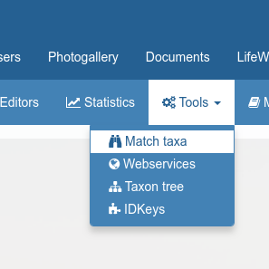

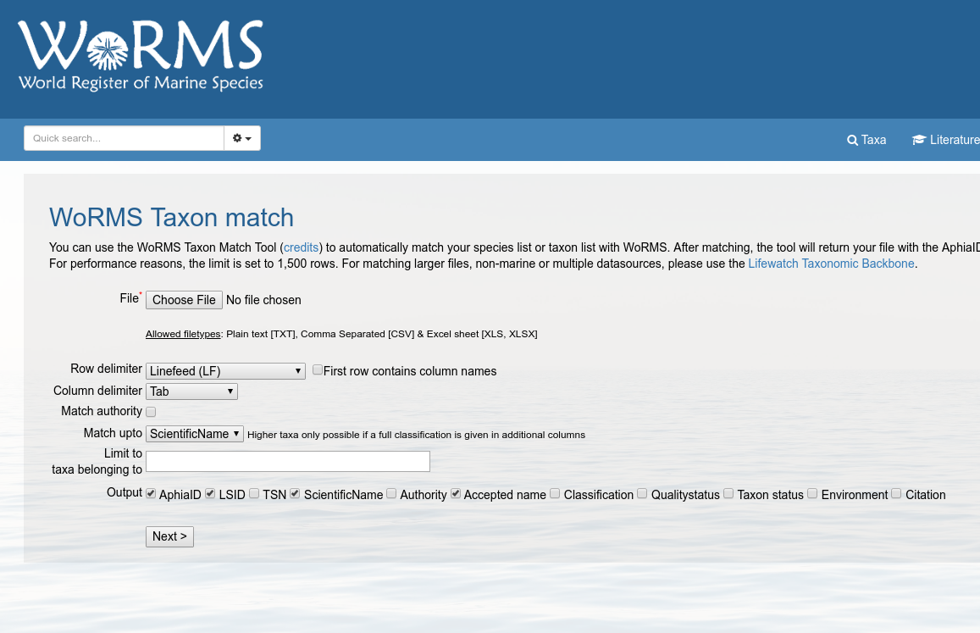

9. ACTION: click on “Choose File”, and select your **taxonameAbund.csv** from your computer.

10. NOTE: **make sure that the option LSID is checked** at the bottom before click Next. Click Next then.

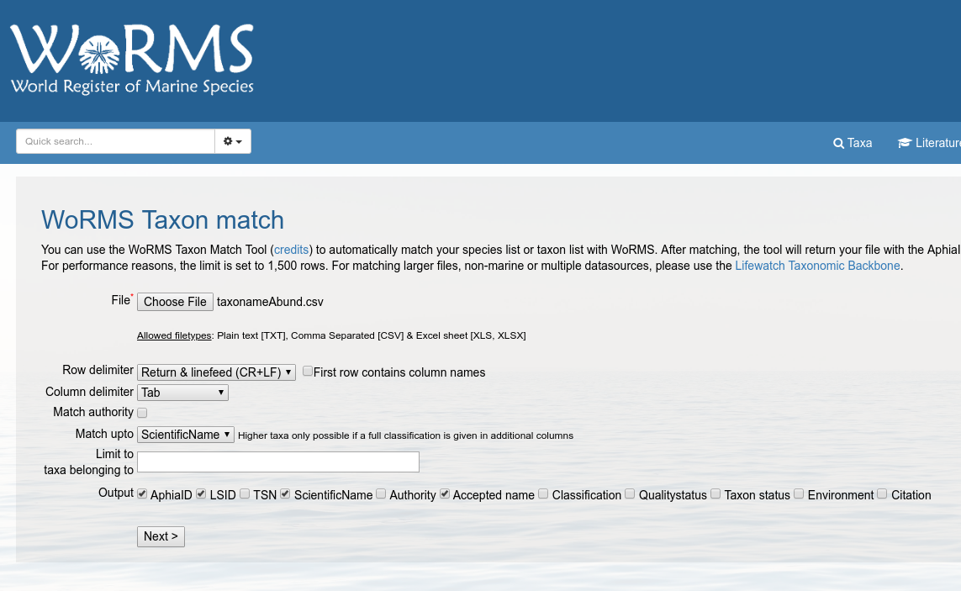

11. You will have a preview of the content of your **taxonameAbund.csv** file saying that the column represent the scientific name of the organism. If you’re satisfied with that, click “Match”. You will have something similar to this:

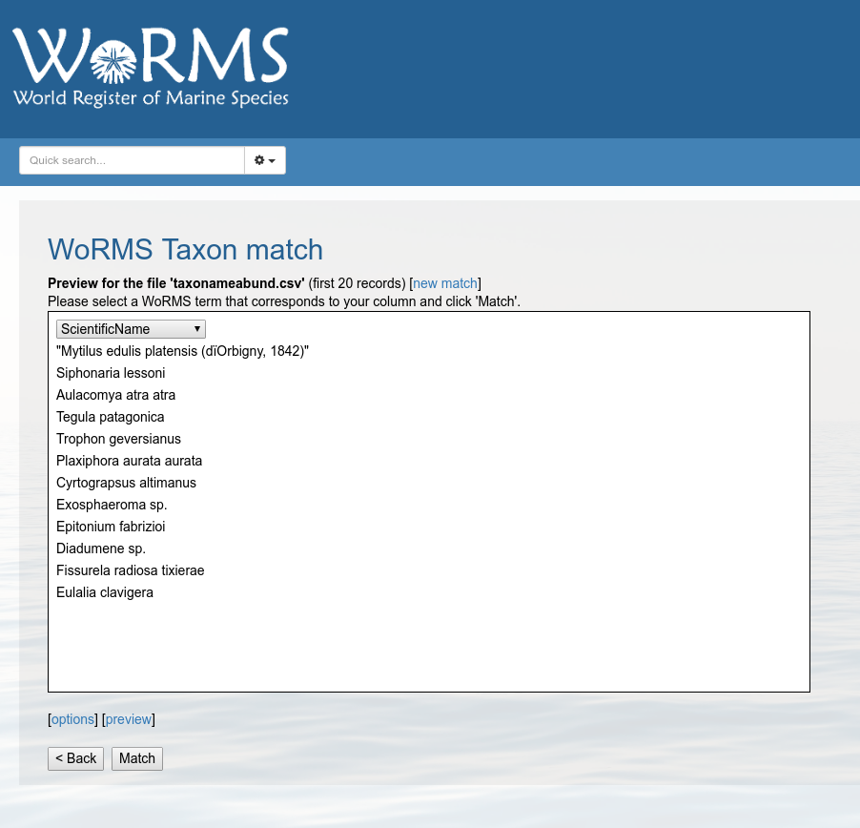

12. You will probably have some mismatched that could be caused by an ambiguity in the authority. You have to resolve each of them using the pull down menu in each of the taxon with problems.

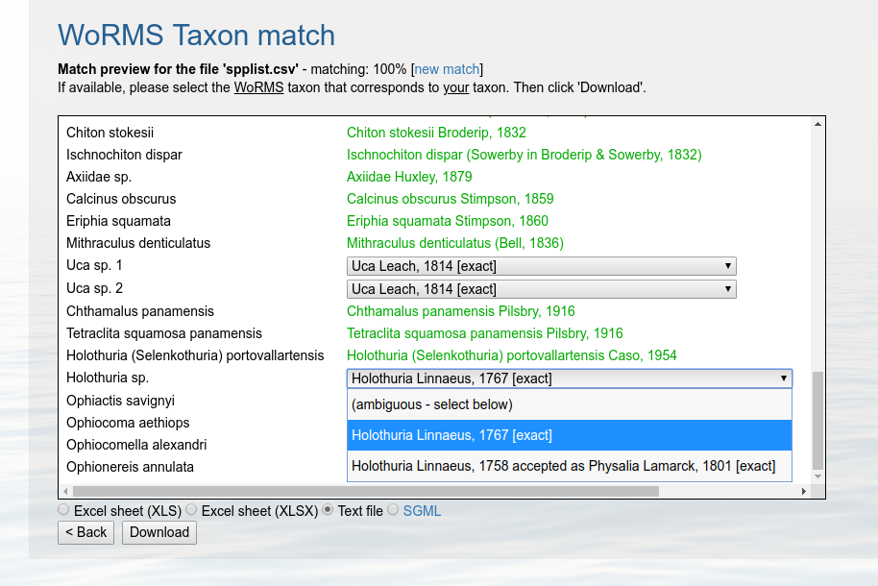

13. You could also have non-matched taxa that appear in red in the WoRM match window. In this case you have provide the correct name in the **original excel table and repeat the match again.**

14. If you’re absolutely certain that your species name is correct but it is not in WoRMS, you can write to WoRM providing the reference of that particular taxon and they will incorporate the name in a very short time (max 1-2 days, normally after few hours).

15. Once you’ve resolved all your ambiguous matches and mismatches, you click on **Download** and **save you file as *text file***. WoRMS will save a txt file with the matching information for each of your taxa.

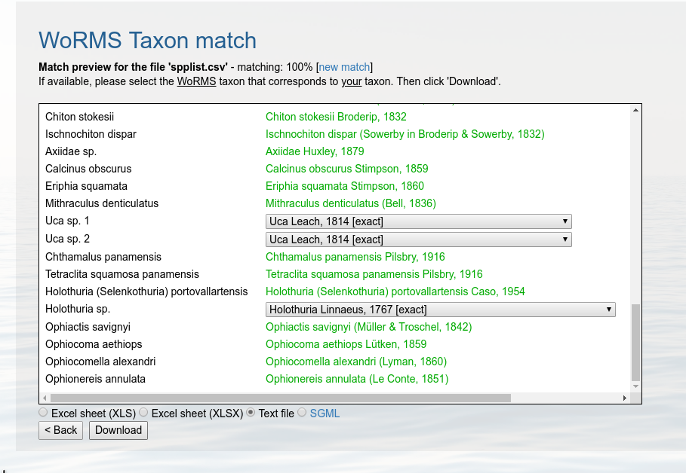

If you follow all the steps, you will have a new file, **taxonameAbund_matched.txt** which is needed for the processing of your original tables and the dashboard.